**Swing-Up Control**

**Topics Covered**

• Energy control.

• Nonlinear control.

• Control switching logic.

**Prerequisites**

• Filtering laboratory experiment.

• Rotary Pendulum Modeling laboratory experiment.

• Rotary pendulum module is attached to the QUBE-Servo 2.

**1 Background**

**1.1 Energy Control**

In theory, if the arm angle is kept constant and the pendulum is given an initial perturbation, the pendulum will keep on swinging with constant amplitude. The idea of energy control is based on the preservation of energy in ideal systems: The sum of kinetic and potential energy is constant. However, friction will be damping the oscillation in practice and the overall system energy will not be constant. It is possible to capture the loss of energy with respect to the pivot acceleration, which in turn can be used to find a controller to swing up the pendulum.

The dynamics of the pendulum can be redefined in terms of the pivot acceleration *u* as

1 1

*Jp α*¨ + 2 *Mp gLp* sin *α* = 2 *Mp gu* cos *α.* (1.1)

Here, *u* is the linear acceleration of the pendulum.

The potential energy of the pendulum is

and the kinetic energy is

1

*Ep* = 2 *Mp gLp* (1 *−* cos *α*) *,*

*E* = 1 *J α*˙ 2 *.*

*k* 2 *p*

The pendulum angle *α* and the lengths of the pendulum are illustrated in the free body diagram in Figure 1.1.

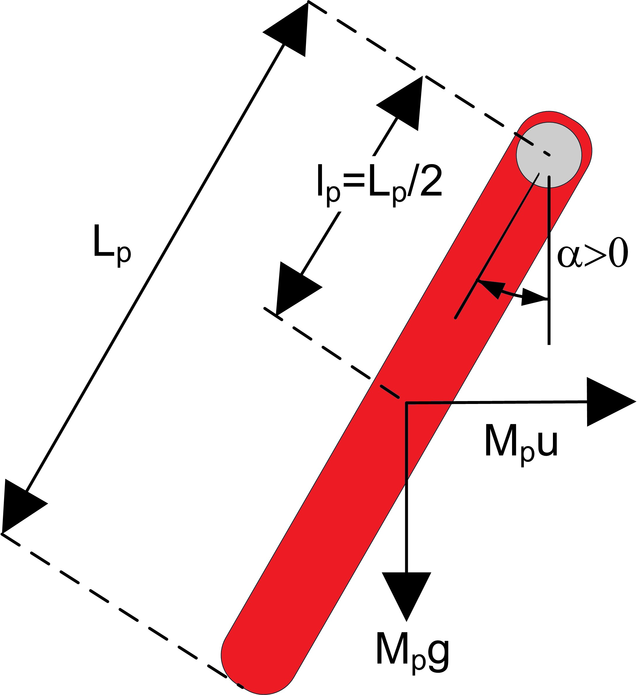

Figure 1.1: Free-body diagram of pendulum

The potential energy is zero when the pendulum is at rest at *α* = 0 and equals *Mp gLp* when the pendulum is upright at *α* = *±π*. The sum of the potential and kinetic energy of the pendulum is

*E* =

Differentiating Equation Equation 1.2 yields

*Jp α*˙ 2 +

1

2

1

2 *Mp gLp* (1 *−* cos *α*) *.* (1.2)

*E*˙ = *α*˙

(

*Jp α*¨ +

1 )

2 *Mp gLp* sin *α*

*.* (1.3)

Recalling Equation (Equation 1.1) and rearranging terms as

*Jp α*¨ = *−Mp glp* sin *α* + *Mp ulp* cos *α*

eventually yields

*E*˙ = *Mp ulp α*˙ cos *α.*

Since the acceleration of the pivot is proportional to current driving the arm motor and thus also proportional to the drive voltage, it is possible to control the energy of the pendulum with the proportional control law

*u* = (*Er − E*)*α*˙ cos *α.* (1.4)

By setting the reference energy to the pendulum potential energy (*Er* = *Ep* ), the control law will swing the link to its upright position. Notice that the control law is nonlinear because the proportional gain depends on the cosine of the pendulum angle *α*. Further, the control changes sign when *α*˙ changes sign and when the angle is *±*90 degrees.

For the system energy to change quickly, the magnitude of the control signal must be large. As a result the following swing-up controller is implemented in the controller as

*u* = sat*umax* (*µ*(*Er − E*)sign(*α*˙ cos *α*)) (1.5)

where *µ* is a tunable control gain and the sat*umax* function saturates the control signal at the maximum acceleration of the pendulum pivot, *umax* . The expression sign(*α*˙ cos *α*) is used to enable faster control switching.

**1.2 Hybrid Swing-Up Control**

The energy swing-up control in Equation 1.4 (or Equation 1.5) can be combined with the balancing control law from the Balance Control Lab to obtain a control law that swings up the pendulum and then balances it.

Similarly as described in the Balance Control Lab, the balance control is to be enabled when the pendulum is within *±*20 degrees. When it is not enabled, the swing-up control is engaged. Thus the switching can be described mathematically by:

{*ubal* if *|α| − π ≤* 20*◦*

*u* =

*uswing*_*up* otherwise

(1.6)

**2 In-Lab Exercises**

The VI shown in Figure 2.1 swings-up and balances the pendulum on the QUBE-Servo 2 Rotary Pendulum system. The *Swing-Up Control* subsystem implements the energy control described in Background section of this lab.

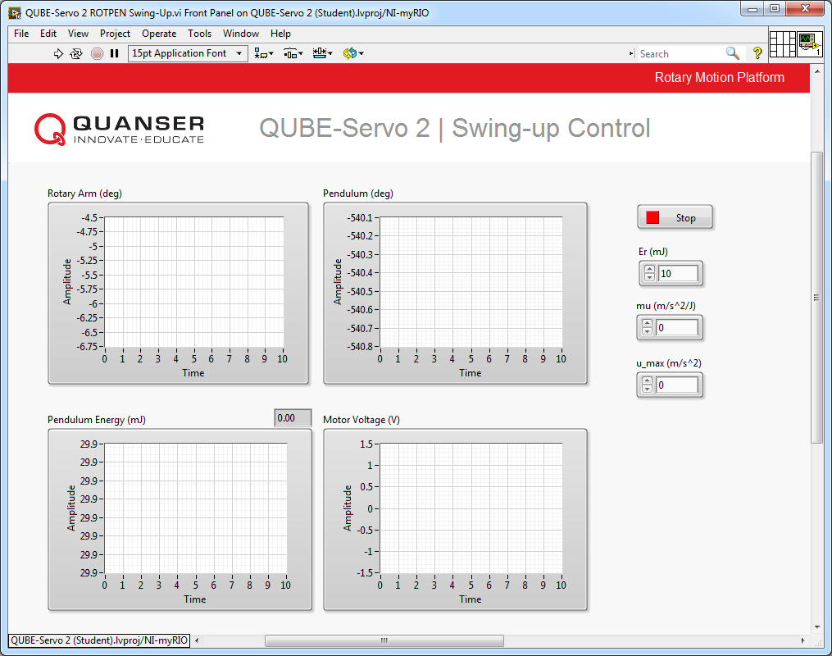

(a) Front Panel

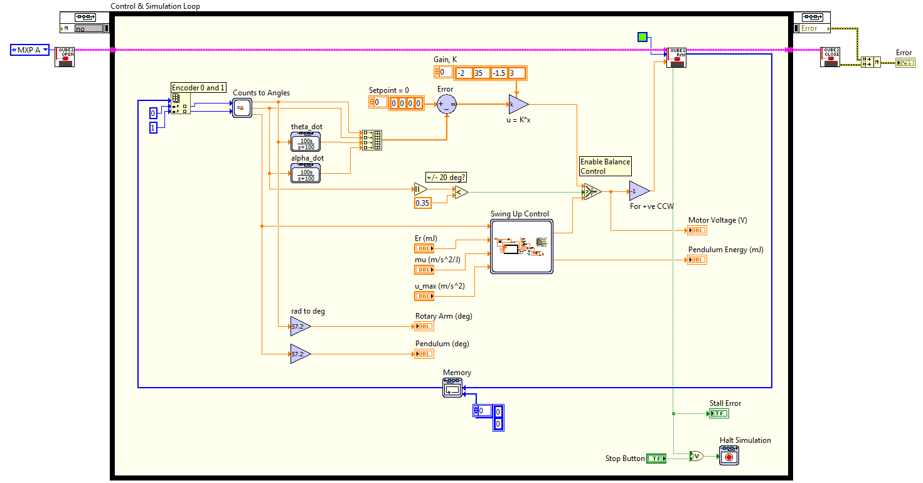

(b) Block Diagram

Figure 2.1: VI that implements the swing-up controller

**2.1 Energy Control**

1. Open QUBE-Servo 2 ROTPEN Swing-Up.vi.

2. To turn the swing-up control off, set mu to 0.

3. Run the VI.

4. Manually rotate the pendulum at different levels and examine the pendulum angle and energy in the Pendulum

(deg) and Pendulum Energy (mJ) charts.

5. What do you notice about the energy when the pendulum is moved at different positions? Record the energy when the pendulum is being balanced upright. Does this reading make sense in terms of the equations developed in the Background section of this lab?

6. Click on the Stop button to bring the pendulum down to the initial, downward position.

7. Set the swing-up control parameters (Constant and Gain blocks connected to the inputs of the Swing-Up Control

subsystem) to the following values:

• mu (m/s2 /J) = 50

• Er (mJ) = 10.0

• u_max (m/s2 ) = 6

8. If the pendulum is not moving, gently perturb the pendulum with your hand from the downward position.

9. Vary the reference energy, Er, between 10*.*0 mJ and 20*.*0 mJ. As it is changed, examine the pendulum angle and energy response in Pendulum (deg) and the Pendulum Energy (mJ) charts and the control signal in the Motor Voltage (V) chart. Attach the responses showing how changing the reference energy affects the system.

10. Fix Er to 20*.*0 mJ and vary the swing-up control gain *mu* between 20 and 60 m/s2 /J. Describe how this changes the performance of the energy control.

11. Click on the Stop button to stop the VI.

**2.2 Hybrid Swing-Up Control**

1. Open QUBE-Servo 2 ROTPEN Swing-Up (Student).vi.

2. Set the swing-up control parameters to the following:

• mu (m/s2 /J) = 20

• u_max (m/s2 ) = 6

3. Based on your observations in the previous lab, 2.1, what should the reference energy be set to?

4. Make sure the pendulum is hanging down motionless and the encoder cable is not interfering with the pendulum.

5. Run the VI.

6. The pendulum should begin going back and forth. If not, perturb the pendulum lightly with your hand. **Click on the Stop button if the pendulum goes unstable.**

7. Gradually increase the swing-up gain *µ* until the pendulum swings up to the vertical position. Capture a response of the swing-up and record the swing-up gain that was required. Show the pendulum angle, pendulum energy, and motor voltage.

8. Click on the Stop button to stop the VI.

© 2017 Quanser Inc., All rights reserved.

Quanser Inc.

119 Spy Court Markham, Ontario L3R 5H6

Canada [info@quanser.com](mailto:info@quanser.com) Phone: 1-905-940-3575

Fax: 1-905-940-3576

Printed in Markham, Ontario.

For more information on the solutions Quanser Inc. offers, please visit the web site at:

[http://www.quanser.com](http://www.quanser.com/)

This document and the software described in it are provided subject to a license agreement. Neither the software nor this document may be used or copied except as specified under the terms of that license agreement. Quanser Inc. grants the following rights: a) The right to reproduce the work, to incorporate the work into one or more collections, and to reproduce the work as incorporated in the collections, b) to create and reproduce adaptations provided reasonable steps are taken to clearly identify the changes that were made to the original work, c) to distribute and publically perform the work including as incorporated in collections, and d) to distribute and publicly perform adaptations. The above rights may be exercised in all media and formats whether now known or hereafter devised. These rights are granted subject to and limited by the following restrictions: a) You may not exercise any of the rights granted to You in above in any manner that is primarily intended for or directed toward commercial advantage or private monetary compensation, and b) You must keep intact all copyright notices for the Work and provide the name Quanser Inc. for attribution. These restrictions may not be waved without express prior written permission of Quanser Inc.